ASSIGNMENT 2
PYTHON-CSA0806

Name: RAHUL S
RegNo:1965260203

TASK 1 :
Program:
import timeit

households = [
(50, False, False, "Full subsidy"),
(100, True, False, "Full subsidy"), # boundary 100
(101, True, False, "Partial subsidy"), # boundary 101
(101, False, False, "No subsidy"), # boundary 101, no card
(200, True, False, "Partial subsidy"), # boundary 200
(200, False, True, "No subsidy"), # age rule does not apply up to 200
(201, False, True, "Senior subsidy"), # boundary 201
(201, True, False, "No subsidy"), # card does not help above 200
]

def decide_buggy(units, ration, senior):
results = []
if units <= 100:
results.append("Full subsidy")
if units <= 200 and ration: # BUG: no lower limit
results.append("Partial subsidy")
if units > 200 and senior:
results.append("Senior subsidy")
if not results:
results.append("No subsidy")
return results

def decide_separate_if(units, ration, senior):
results = []
if units <= 100:
results.append("Full subsidy")
if 101 <= units <= 200 and ration:
results.append("Partial subsidy")
if units > 200 and senior:
results.append("Senior subsidy")
if not results:
results.append("No subsidy")
return results

def decide_elif(units, ration, senior):
if units <= 100:
return "Full subsidy"
elif 101 <= units <= 200 and ration:
return "Partial subsidy"
elif units > 200 and senior:
return "Senior subsidy"
else:
return "No subsidy"

SLABS = [
(100, "always"),
(200, "ration"),
(float("inf"), "senior"),
]

def decide_table(units, ration, senior):
for limit, rule in SLABS:
if units <= limit:
if rule == "always":
return "Full subsidy"
if rule == "ration":
return "Partial subsidy" if ration else "No subsidy"
return "Senior subsidy" if senior else "No subsidy"

print("=" * 95)
print(f"{'Units':<6}{'Card':<7}{'80+':<7}{'Predicted':<17}{'if-elif-else':<17}"
f"{'Separate if':<22}{'Buggy ifs':<22}")
print("=" * 95)

all_ok = True
for units, ration, senior, predicted in households:
a = decide_elif(units, ration, senior)
b = decide_separate_if(units, ration, senior)
c = decide_buggy(units, ration, senior)
d = decide_table(units, ration, senior)

if a != predicted or b != [predicted] or d != predicted:
all_ok = False

print(f"{units:<6}{str(ration):<7}{str(senior):<7}{predicted:<17}{a:<17}"
f"{', '.join(b):<22}{', '.join(c):<22}")
if len(c) > 1:
print(" ^^^ buggy version gave MORE THAN ONE result here!")

print("-" * 95)
print("All predictions match the correct implementations:", all_ok)
print("\nTiming 200000 decisions for the worst case (units=250):")
runs = 200000
t1 = timeit.timeit(lambda: decide_separate_if(250, False, True), number=runs)
t2 = timeit.timeit(lambda: decide_elif(250, False, True), number=runs)
t3 = timeit.timeit(lambda: decide_table(250, False, True), number=runs)
print(f"Separate if : {t1:.4f} seconds")
print(f"if-elif-else : {t2:.4f} seconds")
print(f"Lookup table : {t3:.4f} seconds")

OUTPUT:
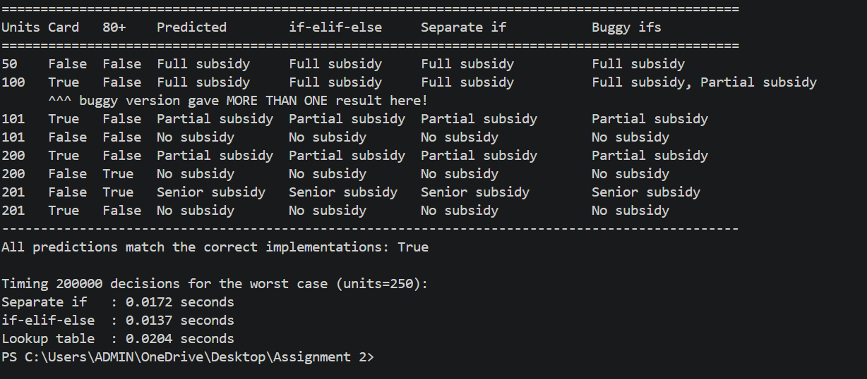

TASK 2
Program:
import timeit

OTP = "4821"
SECURITY_ANSWER = "chennai"
GRANTED = "Access granted"
LOCKED = "Account locked for 30 minutes"

def while_version(entries):
entries = list(entries)
attempts = 0
result = ""
while attempts < 3:
entry = entries.pop(0)
if entry == "":
continue
attempts += 1
if entry == OTP:
result = GRANTED
break
else:
result = LOCKED
return result

def for_version(entries):
entries = list(entries)
result = ""
for attempt in range(3):
while True:
entry = entries.pop(0)
if entry == "":
pass
else:
break
if entry == OTP:
result = GRANTED
break
else:
result = LOCKED
return result

def buggy_while(entries):
entries = list(entries)
attempts = 0
result = ""
while attempts < 3:
entry = entries.pop(0)
attempts += 1 # BUG: counted before the blank check
if entry == "":
continue
if entry == OTP:
result = GRANTED
break
else:
result = LOCKED
return result

def extended_while(entries, security_answer):
entries = list(entries)
limit = 3
attempts = 0
extended = False
result = ""
while attempts < limit:
entry = entries.pop(0)
if entry == "":
continue
attempts += 1
if entry == OTP:
result = GRANTED
break

if attempts == limit and not extended and security_answer == SECURITY_ANSWER:
limit = 5 # two extra attempts
extended = True
else:
result = LOCKED
return result

def recursive_version(entries, attempts=0):
if attempts == 3:
return LOCKED
entry = entries.pop(0)
if entry == "":
return recursive_version(entries, attempts) # blank: same attempt number
if entry == OTP:
return GRANTED
return recursive_version(entries, attempts + 1) # wrong: next attempt

scenarios = [
("Correct on 1st try", ["4821"]),
("Correct on 3rd try", ["1111", "2222", "4821"]),
("Blanks do not count", ["1111", "", "2222", "4821"]),
("Three wrong -> locked", ["1111", "2222", "3333"]),
("Blanks then 3 wrong", ["", "", "1111", "2222", "3333"]),
]

print("=" * 88)
print(f"{'Scenario':<24}{'while':<30}{'for':<30}")
print("=" * 88)
for name, entries in scenarios:
print(f"{name:<24}{while_version(entries):<30}{for_version(entries):<30}")

print("\nRecursion version (same scenarios):")
for name, entries in scenarios:
print(f" {name:<24}{recursive_version(list(entries))}")

print("\nBug demo (counter updated before the blank check):")
demo = ["1111", "", "2222", "4821"]
print(" Entries :", demo)
print(" Correct while loop :", while_version(demo))
print(" Buggy while loop :", buggy_while(demo), "<-- wrong! blank was counted")

print("\nChanged condition (2 extra attempts after the security question):")
five = ["1111", "2222", "3333", "4444", "4821"]
print(" Right security answer:", extended_while(five, "chennai"))
print(" Wrong security answer:", extended_while(five, "delhi"))
print(" Right answer, 5 wrong:", extended_while(["1", "2", "3", "4", "5"], "chennai"))
print("\nTiming 100000 runs of the worst case (3 wrong entries):")
worst = ["1111", "2222", "3333"]
runs = 100000
t1 = timeit.timeit(lambda: while_version(worst), number=runs)
t2 = timeit.timeit(lambda: for_version(worst), number=runs)
t3 = timeit.timeit(lambda: recursive_version(list(worst)), number=runs)
print(f"while loop : {t1:.4f} seconds")
print(f"for loop : {t2:.4f} seconds")
print(f"recursion : {t3:.4f} seconds")

OUTPUT:
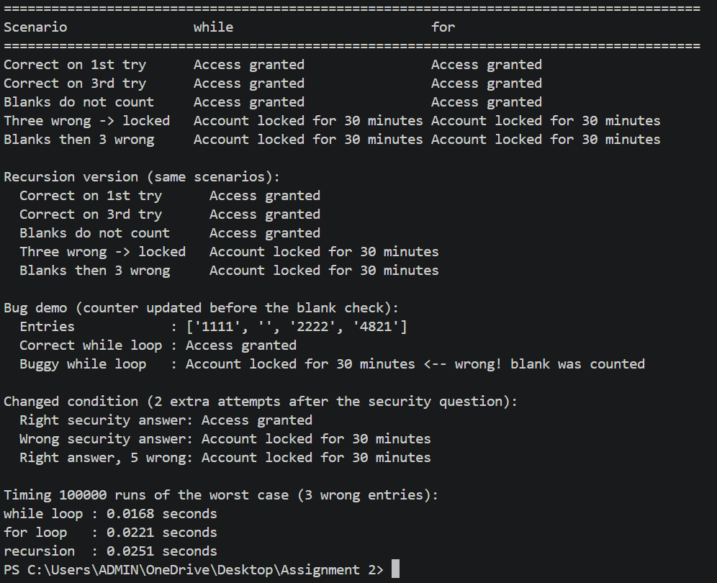
TASK 3:
Program:
import re
import timeit

def normalise(text):
"""'tn 09 ab 1234' -> 'TN09AB1234' (spaces and hyphens removed, upper case)."""
return text.strip().replace(" ", "").replace("-", "").upper()

def is_valid(reg):
"""Valid form: 2 letters, 2 digits, 1 or 2 letters, 4 digits (e.g. TN09AB1234)."""
if len(reg) != 9 and len(reg) != 10:
return False
state = reg[:2] # first 2 characters
district = reg[2:4] # next 2 characters
series = reg[4:-4] # everything between, 1 or 2 characters
number = reg[-4:] # last 4 characters
return (state.isalpha() and district.isdigit()
and series.isalpha() and number.isdigit())

def format_plate(reg):
"""'TN09AB1234' -> 'TN 09 AB 1234'"""
if not is_valid(reg):
return "Cannot format: invalid number"
return " ".join([reg[:2], reg[2:4], reg[4:-4], reg[-4:]])

def is_valid_regex(reg):
return re.fullmatch(r"[A-Z]{2}[0-9]{2}[A-Z]{1,2}[0-9]{4}", reg) is not None

print("PART 1: Given test loop")
for raw in ["tn 09 ab 1234", "KA-01-M-0007", "TN9AB1234", "TN 22 1234 AB"]:
reg = normalise(raw)
print(f"{raw:15} -> {reg:11} {'valid' if is_valid(reg) else 'INVALID'}")

predictions = [
("tn 09 ab 1234", "TN09AB1234", True),
("TN-09-AB-1234", "TN09AB1234", True),
("Tn09Ab1234", "TN09AB1234", True),
("ka-01-m-0007", "KA01M0007", True),
("TN 09 ABC 1234", "TN09ABC1234", False), # length 11, rejected
("TN 0A AB 1234", "TN0AAB1234", False), # '0A' is not 2 digits, rejected
]

print("\nPART 2: Predicted vs observed")
print(f"{'Typed':<16}{'Normalised':<13}{'Valid':<7}{'Receipt format':<18}{'Match'}")
print("-" * 62)
all_ok = True
for raw, pred_reg, pred_valid in predictions:
reg = normalise(raw)
valid = is_valid(reg)
match = (reg == pred_reg and valid == pred_valid
and valid == is_valid_regex(reg))
if not match:
all_ok = False
print(f"{raw:<16}{reg:<13}{str(valid):<7}{format_plate(reg):<18}{match}")
print("-" * 62)
print("All predictions correct:", all_ok)

print("\nPART 3: Slicing demo")
for plate in ["KA01M0007", "TN09AB1234"]:
print(f"{plate} (length {len(plate)}): s[-4:] = {plate[-4:]!r}, s[4:-4] = {plate[4:-4]!r}")

text = "tn09ab1234"
text.upper()
print("\nAfter text.upper() without saving:", text)
text = text.upper()
print("After text = text.upper() :", text)
try:
text[0] = "X"
except TypeError as error:
print("Trying text[0] = 'X' gives TypeError:", error)

print("\nPART 4: Timing 200000 validations of 'TN09AB1234'")
runs = 200000
t1 = timeit.timeit(lambda: is_valid("TN09AB1234"), number=runs)
t2 = timeit.timeit(lambda: is_valid_regex("TN09AB1234"), number=runs)
print(f"Slicing + string methods : {t1:.4f} seconds")
print(f"Regular expression : {t2:.4f} seconds")

OUTPUT:

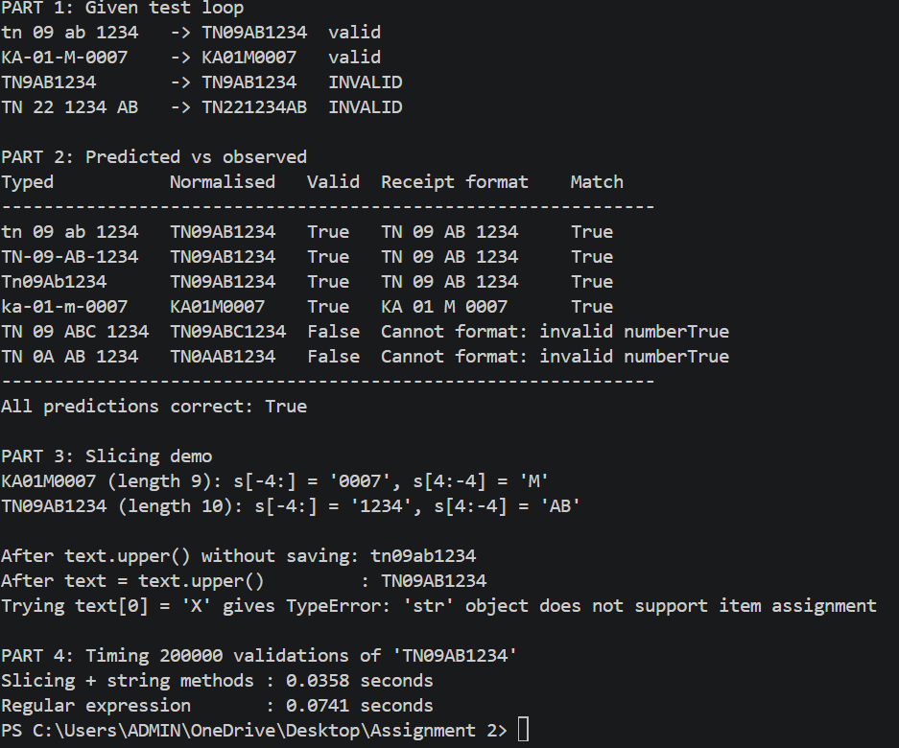

Task 4:
Program:
import time

# ---------- Data ----------
items = [f"Item{i}:Rs{i % 50}" for i in range(200_000)]

# ---------- (a) repeated += ----------
def build_plus(parts):
text = ""
for p in parts:
text += p + ";"
return text

# ---------- (b) list of parts + join() ----------
def build_join(parts):
# TODO 1 (completed): single str.join() call
return "".join([p + ";" for p in parts])

# ---------- (c) f-string for each line, then join ----------
def build_fstring(parts):
lines = []
for p in parts:
lines.append(f"{p};")
return "".join(lines)

# ---------- Part 1: the given check ----------
start = time.perf_counter(); a = build_plus(items); t_plus = time.perf_counter() - start
start = time.perf_counter(); b = build_join(items); t_join = time.perf_counter() - start

print("same text:", a == b, "| length:", len(b))
print(f"+= time: {t_plus:.4f} s join time: {t_join:.4f} s")
print()

# ---------- Part 2: measure all three at 1,000 / 10,000 / 200,000 lines ----------
def measure(func, data):
start = time.perf_counter()
func(data)
return time.perf_counter() - start

sizes = [1_000, 10_000, 200_000]
runs = 3

print(f"{'Lines':>8} | {'+= (s)':>10} | {'join (s)':>10} | {'f-string (s)':>12}")
print("-" * 50)

for n in sizes:
data = items[:n]
total_plus = total_join = total_f = 0

for _ in range(runs):
total_plus += measure(build_plus, data)
total_join += measure(build_join, data)
total_f += measure(build_fstring, data)

print(f"{n:>8} | {total_plus / runs:>10.5f} | {total_join / runs:>10.5f} | {total_f / runs:>12.5f}")

# ---------- Part 3: all three give the same text ----------
print()
print("All three equal:", build_plus(items) == build_join(items) == build_fstring(items))

OUTPUT:
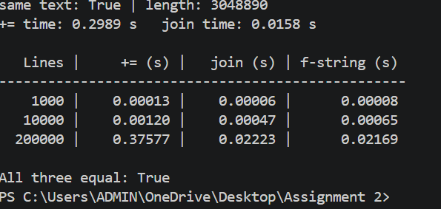

TASK 5
PROGRAM:

def add_item_buggy(item, order=[]):
# the [] is created ONCE, when the function is defined
order.append(item)
return order

def add_item(item, order=None):
# TODO 1 (completed)
if order is None:
order = []
order.append(item)
return order

print("--- Part 1: Bug vs Fix ---")
print(add_item_buggy("Tea"), add_item_buggy("Vada"))
print(add_item("Tea"), add_item("Vada"))

# Python stores default values in __defaults__
print("Buggy defaults:", add_item_buggy.__defaults__)
print("Fixed defaults:", add_item.__defaults__)

def make_line(item, qty=1, price=10):
# item -> positional (required)
# qty, price -> default parameters (optional)
return item + " x" + str(qty) + " = Rs." + str(qty * price)

print("\n--- Part 2: Positional, keyword and default parameters ---")
print(make_line("Tea")) # positional + defaults
print(make_line("Vada", 2, 12)) # all positional
print(make_line("Dosa", price=40, qty=2)) # keyword (order does not matter)

def calculate_bill(prices, gst_percent=5):
total = sum(prices)
gst = total * gst_percent / 100
return total, gst # returns a tuple (total, gst)

print("\n--- Part 3: Returning two values ---")
total, gst = calculate_bill([10, 12, 40])
print("Total:", total, "GST:", gst, "Grand total:", total + gst)

print("\n--- Part 4: Scope ---")

def local_demo():
message = "I am local"
print(message)

local_demo()

orders_served = 0

def serve_without_global():
orders_served = 100

def serve_with_global():
global orders_served
orders_served = orders_served + 1

serve_without_global()
print("After serve_without_global:", orders_served) # still 0
serve_with_global()
print("After serve_with_global:", orders_served) # 1

def outer():
count = 0

def inner():
nonlocal count
count = count + 1

inner()
inner()
return count

print("Nonlocal demo (inner called twice):", outer()) # 2

def add_item_explicit(item, order):
order.append(item)
return order

def new_customer():
order = []

def add(item):
order.append(item)
return order

return add

print("\n--- Part 5: Test with three customers ---")

# Design 1: default None
c1 = add_item("Tea")
c1 = add_item("Vada", c1)
c2 = add_item("Coffee")
c3 = add_item("Dosa")
c3 = add_item("Idli", c3)
print("Customer 1:", c1)
print("Customer 2:", c2)
print("Customer 3:", c3)

# Design 2: explicit list
a1, a2, a3 = [], [], []
add_item_explicit("Tea", a1)
add_item_explicit("Coffee", a2)
add_item_explicit("Dosa", a3)
print("Explicit :", a1, a2, a3)

# Design 3: closure
cust1 = new_customer()
cust2 = new_customer()
cust3 = new_customer()
cust1("Tea")
cust1("Vada")
cust2("Coffee")
print("Closure :", cust1("Samosa"), cust2("Biscuit"), cust3("Dosa"))
OUTPUT:
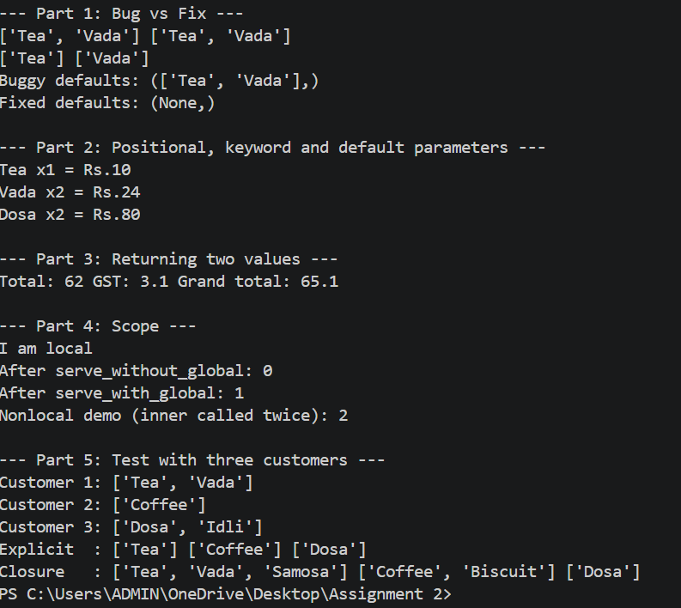

TASK 6:
PROGRAM:
import sys
from functools import lru_cache

calls = 0

def ways_naive(n):
"""Ways to climb n temple steps taking 1 or 2 steps at a time."""
global calls
calls += 1
if n <= 1: # base case
return 1
return ways_naive(n - 1) + ways_naive(n - 2) # recursive case

@lru_cache(maxsize=None)
def ways_memo(n):
global calls
calls += 1
# TODO 1 (completed): same base case and recursive case, calling ways_memo
if n <= 1:
return 1
return ways_memo(n - 1) + ways_memo(n - 2)

def ways_loop(n):
"""Loop version: keeps only the last two values."""
previous, current = 1, 1
for _ in range(2, n + 1):
previous, current = current, previous + current
return current

calls = 0; print("naive:", ways_naive(25), "calls =", calls)
ways_memo.cache_clear()
calls = 0; print("memo :", ways_memo(25), "calls =", calls)

print("\nCorrectness check (hand answers: 1, 2, 3, 5, 8, 13)")
hand = [1, 2, 3, 5, 8, 13]
for n in range(1, 7):
result = ways_loop(n)
print("n =", n, "naive =", ways_naive(n), "memo =", ways_memo(n),
"loop =", result, "hand =", hand[n - 1],
"OK" if result == hand[n - 1] else "WRONG")

print("\nGrowth investigation (function calls)")
print("n naive_calls memo_calls")
for n in [10, 20, 25, 30]:
calls = 0
ways_naive(n)
naive_calls = calls

ways_memo.cache_clear() # empty the cache so the count is fair
calls = 0
ways_memo(n)
memo_calls = calls

print(n, " ", naive_calls, " ", memo_calls)

print("\nDeployment test for n = 1000")
print("Recursion limit:", sys.getrecursionlimit())

ways_memo.cache_clear()
try:
ways_memo(1000)
except RecursionError:
print("RecursionError: memoised version needs about 1000 nested calls,")
print("which is more than the limit allows.")

sys.setrecursionlimit(5000)
ways_memo.cache_clear()
big_memo = ways_memo(1000)
print("After raising limit to", sys.getrecursionlimit(), "-> memo works")

big_loop = ways_loop(1000)
print("Loop version works with the default limit too")

print("memo and loop give same answer:", big_memo == big_loop)
print("Number of digits in answer:", len(str(big_loop)))
print("First 20 digits:", str(big_loop)[:20])

OUTPUT:
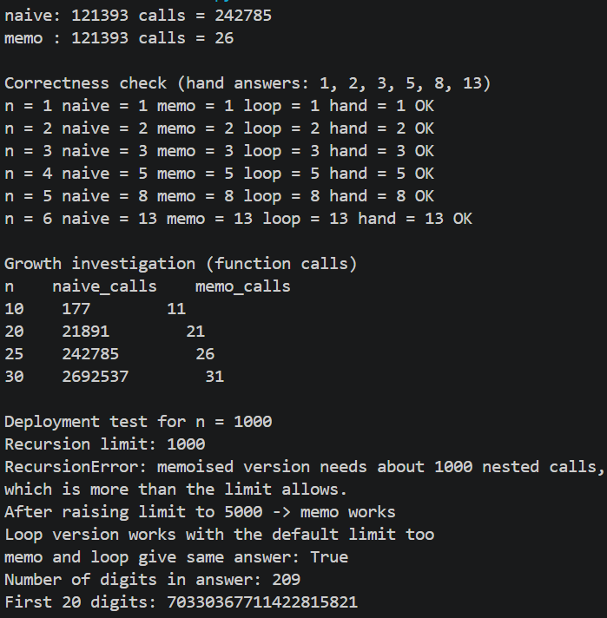

TASK 7:
PROGRAM:
import sys
import time

# ======================================================
# ORIGINAL DESIGN (from Q6): plain recursion
# ======================================================
calls = 0

def ways_naive(n):
global calls
calls += 1
if n <= 1:
return 1
return ways_naive(n - 1) + ways_naive(n - 2)

# ======================================================
# PART A: Diagnose - how many times is each n computed?
# ======================================================
repeat_count = {}

def ways_naive_tracked(n):
repeat_count[n] = repeat_count.get(n, 0) + 1
if n <= 1:
return 1
return ways_naive_tracked(n - 1) + ways_naive_tracked(n - 2)

print("=== A. DIAGNOSIS: ways_naive(10) ===")
ways_naive_tracked(10)
print("Value of n Times it was computed")
for n in range(10, -1, -1):
print(" ", n, " ", repeat_count[n])
total_calls = sum(repeat_count.values())
print("Total calls:", total_calls, "but only 11 different values of n exist")
print("Wasted (repeated) calls:", total_calls - 11)

# ======================================================
# REDESIGN 1 (intermediate): our own dictionary memo
# ======================================================
memo_calls = 0

def ways_dict_memo(n, saved=None):
global memo_calls
memo_calls += 1
if saved is None:
saved = {}
if n in saved: # already solved: just look it up
return saved[n]
if n <= 1:
saved[n] = 1
else:
saved[n] = ways_dict_memo(n - 1, saved) + ways_dict_memo(n - 2, saved)
return saved[n]

# ======================================================
# REDESIGN 2 (final): bottom-up loop, keep only last two values
# ======================================================
loop_additions = 0

def ways_loop(n):
global loop_additions
previous, current = 1, 1
for _ in range(2, n + 1):
previous, current = current, previous + current
loop_additions += 1
return current

# ======================================================
# PART E: Validate - same inputs, same measures
# ======================================================
print("\n=== E. VALIDATION ===")

# 1. Correctness: all versions must agree
all_same = True
for n in range(1, 26):
if not (ways_naive(n) == ways_dict_memo(n) == ways_loop(n)):
all_same = False
print("All three versions agree for n = 1 to 25:", all_same)

# 2. Operation counts and time
print("\n n | naive calls | memo calls | loop adds | naive time(s) | loop time(s)")
for n in [10, 20, 25, 30]:
calls = 0
start = time.perf_counter()
ways_naive(n)
naive_time = time.perf_counter() - start
naive_count = calls

memo_calls = 0
ways_dict_memo(n)
memo_count = memo_calls

loop_additions = 0
start = time.perf_counter()
ways_loop(n)
loop_time = time.perf_counter() - start
loop_count = loop_additions

print(f"{n:3d} | {naive_count:11d} | {memo_count:10d} | {loop_count:9d} |"
f" {naive_time:13.6f} | {loop_time:.8f}")

# 3. Improvement ratio at n = 30
calls = 0
ways_naive(30)
loop_additions = 0
ways_loop(30)
print("\nAt n = 30: naive made", calls, "calls, loop made",
loop_additions, "additions")
print("Improvement: about", calls // loop_additions, "times fewer operations")

# 4. The requirement changes: n = 1000
print("\n=== n = 1000 (requirement of the temple trust) ===")
print("Recursion limit:", sys.getrecursionlimit())

try:
ways_dict_memo(1000)
print("Dictionary memo: worked")
except RecursionError:
print("Dictionary memo: RecursionError (too many nested calls)")

loop_additions = 0
answer = ways_loop(1000)
print("Loop: worked, additions =", loop_additions,
", digits in answer =", len(str(answer)))
print("Naive recursion at n = 1000: not run (would need more than 10^200 calls)")

OUTPUT:
